PROJECT REPORT ON

## Solve Quora Question Pair Similarity Problem By using Machine Learning Algorithms

#### SUBMITTED IN PARTIAL FULFILLMENT OF

THE REQUIREMENTS OF THE AWARDS OF THE

**PG-DIPLOMA IN ADVANCED SECURE SOFTWARE DEVELOPMENT**

**OFFERED BY**

**C-DAC HYDERABAD**

#### BY

|  |  |
| --- | --- |
| **ILAVENI RANJITH** | **(210950329009)** |
| **KOMURAVELLI PRIYANKA** | **(210950329011)** |
| **NAMINDLA NAVANITHA** | **(210950329016)** |



**ADVANCED COMPUTING TRAINING SCHOOL C-DAC**

**HYDERABAD-500005 SEP 2021**



#### CERTIFICATE

This is to certify that this is a Bonafide record of a project entitled **“Solve Quora Question Pair Similarity Problem By using Machine Learning Algorithms''** Ilaveni Ranjith 210950329009, Komuravelli Priyanka 210950329011, Namindla Navanitha 201950329016 has completed project work as part of **Diploma in Secure Software Development (Sep 2021 Batch)**, a PG course offered by C-DAC Hyderabad. They have completed project work under the supervision of Mr. Yuvraj Takey. Their Performance found to be Good.

Name of Project guide

(Mr. Yuvraj Takey)

**DATE** :

**PLACE** : C-DAC, HARDWARE PARK, HYDERABAD.

## ACKNOWLEDGEMENT

#### Solve Quora question pair similarity Problem using MachineLearning Algorithm Aim of this project is to Identify which questions asked on Quora are duplicates of questions that have already been asked. This could be useful to instantly provide answers to questions that have already been answered. We are tasked with predicting whether a pair of questions are duplicates or not.

However, we could not have made it without the support and guidance from the Following, Firstly I want to take this opportunity to have special thanks to our guide **Mr. Yuvraj Takey** who helped us throughout this project by providing valuable guidance,advice as well as acquiring all components needed for this project to become a success.

|  |  |
| --- | --- |
|  | (PG-DASSD SEP 2021) |
| **ILAVENI RANJITH** | **210950329009** |
| **KOMURAVELLI PRIYANKA** | **210950329011** |
| **NAMINDLA NAVANITHA** | **210950329016** |

TABLE OF CONTENTS

Solve Quora Question Pair Similarity Problem By using Machine Learning Algorithms 1

ACKNOWLEDGEMENT 3

Abstract : 5

SOLVE QUORA QUESTION PAIR SIMILARITY 5

Chapter-1 INTRODUCTION 1

1.1 Project Requirements: 1

1.2 Problem Statement: 2

1.3 Software & hardware Requirements : 2

1.4 Coding and Testing : 2

1.5 Basic Terminology 2

1.5.2 DataFrame: 2

1.5.3 Supervised Learning: 3

2.1 Importing Libraries 4

Chapter-3 IMPLEMENTATION 8

CHAPTER-4 MACHINE LEARNING MODELS 16

Chapter - 5 Conclusion 20

References 21

## Abstract :

### SOLVE QUORA QUESTION PAIR SIMILARITY

Quora is a website where we will post our questions and get answers from different people. With this website, people will connect and share their answers to questions. The questions and answers are created, edited, and organized by users. Lot of users on Quora website have multiple questions from different users with similar intentions, which will raise the problem of duplicate questions. With duplicate questions we will waste our time on searching for the appropriate answers to the questions.

Detecting duplicate questions would make it easier to find the best answers without wasting much time, which will improve the user experience for writers and readers on Quora.

Our goal of this project is to find the duplicate question pairs on Quora and ignore them by using the Machine Learning Algorithms especially by Classification Models(Logistic Regression, Random Forest, SVM etc..), first we need to collect the data from Kaggle for detection of duplicate questions, and we will do preprocessing and apply the classification models on that large datasets and we will evaluate the model accuracy and at last we will propose the best model based on that accuracy.

### Chapter-1 INTRODUCTION

Quora is a platform where people can ask their questions and get answers from different people, sometimes the questions asked may be asked in different format but the intent was the same . let's discuss it with an example

We have a question like *“How can I be a good geologist?”* and there are some answers to that question. Later someone asks another question like *“What should I do to be a great geologist?”.*

We can see that both the questions are asking the same thing. Even though the wordings in the question are different, the intention of both questions are the same. So the answers will be the same for both questions. That means we can just show the answers to the first question so that the person who is asking the question will get the answers immediately and people who have already answered the first question don’t have to repeat themselves.

If duplicates are allowed, it would corrupt the quality of answers thereby negatively affecting the experience of the person asking the questions, person answering the questions and the person searching the web for an answer (imagine searching Google for a question and finding 3 results from Quora instead of 1). This problem however is not unique to Quora and many organizations have similar issues.

Ideally, what would happen is that once a question is asked, Quora would use some “technique” to find a subset of its existing question database such that this subset contains questions which are “similar” to or about the same topic as the new question being asked. Once this subset has been identified, Quora would employ a machine learning technique to then determine if a duplicate question exists in this selected subset. If yes, it would notify the questioner and point them to it, else it creates the question.

Our job in this project is to develop the machine learning part. We are not concerned with how Quora generates the subset, assume that it is there and works properly.

## Project Requirements:

**Dataset:** KaggleDataset

## Problem Statement:

Identify which questions asked on Quora are duplicates of questions that have already been asked. This could be useful to instantly provide answers to questions that have already been answered. We are tasked with predicting whether a pair of questions are duplicates or not.

## Software & hardware Requirements :

###### Hardware Specification:

* + - * Processor – i3 or more

###### Hard Disk – 50 GB

* + - * Memory – Min 4GB RAM

###### Software Specification:

* + - * Operating System : Windows 7 or more

###### Language: Python

* + - * IDE : Jupyter Notebook

# Coding and Testing :

In this we develops a code using following software languages:

* PYTHON

### Basic Terminology

* + 1. **Dataset:**

A **data set** (or **dataset**) is a collection of data. In the case of tabular data, a data set corresponds to one or more database tables, where every [column](https://en.wikipedia.org/wiki/Column_(database)) of a table represents a particular [variable](https://en.wikipedia.org/wiki/Variable_(computer_science)), and each [row](https://en.wikipedia.org/wiki/Row_(database)) corresponds to a given record of the data set in question. The data set lists values for each of the variables, such as height and weight of an object, for each member of the data set. Data sets can also consist of a collection of documents or files.

### DataFrame:

A Data frame is a two-dimensional data structure.

All the ndarrays must be of the same length. If index is passed, then the length of the index should equal to the length of the arrays.

A pandas DataFrame can be created using various inputs like −

1. Lists
2. dictionary
3. Series
4. Numpy ndarrays

All the ndarrays must be of the same length. If index is passed, then the length of the index should equal to the length of the arrays.

### Supervised Learning:

Supervised Learning is defined as the category of data analysis where the target outcome is known or labeled.

Classification and Regression both belong to Supervised Learning, but the former is applied where the outcome is finite while the latter is for infinite possible values of outcome

A classification model attempts to draw some conclusion from observed values. Given one or more inputs a classification model will try to predict the value of one or more outcomes. Outcomes are labels that can be applied to a dataset.

There are a number of classification models. Classification models include

1. logistic regression,
2. decision tree
3. random forest
4. gradient-boosted tree
5. multilayer perceptron
6. one-vs-rest
7. 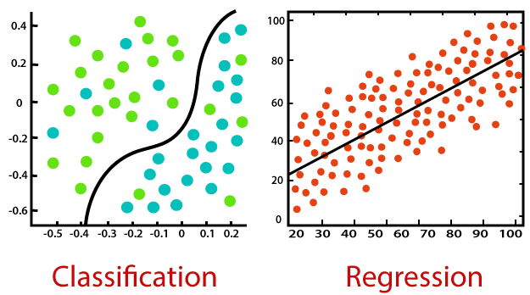Naive Bayes.

**Chapter-2**

**LIBRARIES**

# 2.1 Importing Libraries

|  |  |  |
| --- | --- | --- |
| **Library Name** | **Description** | **Why do we use it?** |
| Numpy  **Command:**  import numpy as np | 1. Numpy is the core library for scientific computing in python. 2. This Library works with multidimensional arrays very efficiently. 3. This is also useful in Linear Algebra, Fourier Transform, and Random Number Capabilities. | 1. Numpy is very efficient when working with   multidimensional arrays.   1. It occupies very less memory, so we can save space and we can use it easily 2. it is very Fast as compared to Lists. |
| Matplotlib  **Command:**  import matplotlib.pyplot as plt | 1. Matplotlib is a cross-platform, data visualization and graphical plotting library for Python. 2. It can be used in python scripts, shell, web application servers and other graphical user interface toolkits. 3. It is a robust, free and easy   library for data visualization. | 1. This Library is Used to plot the 2D Graphs to visualization to understand easily. 2. Matplotlib is effective when we integrate it with other GUI toolkits. |
| Pandas  **Command:**  import pandas as pd | 1. It is a manipulation tool, built on top of Python. 2. It has functions for analyzing, cleaning, exploring, and manipulating data. 3. pandas is a fast, powerful, flexible and easy to use open   source data analysis. | 1. We used it for reading and analyzing the dataset. 2. it has high performance for data analysis 3. It has the ability to handle the missing data in large datasets. |
| Seaborn  **Command:**  import seaborn as sns | 1. Seaborn is an amazing visualization library for statistical graphics plotting in Python. 2. It provides beautiful default styles and color palettes to make statistical plots more   attractive. | 1. Seaborn helps us to explore and understand the data. |

|  |  |  |
| --- | --- | --- |
|  | 3. It is built on the top of Matplotlib Library. |  |
| NLTK  **Command:**  import nltk | 1. The Natural Language Toolkit (NLTK) is a platform used for building Python programs that work with human language data for application in statistical natural language processing (NLP). 2. It contains text processing libraries for tokenization, parsing, classification, stemming, tagging and semantic reasoning. | 1. It is used while performing various NLP tasks during the text processing step. |
| RegEx  **Command:**  import re | 1. It has a built-in package in   Python.   1. It can work with Regular Expressions. | 1. It can be used to search   patterns to find a string.   1. It can be used to detect the absence of a text by matching with a particular pattern |
| Fuzzywuzzy  **Command:**  from fuzzywuzzy import fuzz | 1. Fuzzy string matching is the process of finding strings that match a given pattern. | 1. It is used for string matching. |
| Warnings  **Command:**  import warnings | 1. The warning module is actually a subclass of Exception which is a built-in class in Python. 2. Base category for warnings triggered during the process of importing a module (ignored by default). | 1. This module is used to show warning messages. 2. In order to disable all warnings in the current script/notebook just use filterwarnings(‘ignore’) |
| Distance  **Command:**  import distance | 1. This helps for computing similarities between arbitrary sequences 2. All distance computations are implemented in pure Python, and most of them are also   implemented in C. |  |
| WordCloud  **Command:**  from wordcloud import WordCloud, STOPWORDS | 1. It is a data visualization technique,used for representing text data. 2. The size of each word indicates its frequency. | 1.It is widely used for analyzing data from social network websites. |

|  |  |  |
| --- | --- | --- |
|  |  |  |
| MinMaxScaler **Command:** from  sklearn.preprocessi ng import  MinMaxScaler | 1. It is a scaling algorithm for continuous variables. 2. It is a type of scaler that scales the values that scales the minimum and maximum values to be 0 and 1. | 1. It is used for feature scaling purposes. 2. It is a class from sklearn.preprocessing which is used for normalization. |
| TSNE  **Command:**  from  sklearn.manifold import TSNE | 1.T-distributed Stochastic Neighbor Embedding.  2.It is a class from sklearn.manifold | 1.t-SNE is a dimensionality reduction technique used to represent high dimensional dataset to low dimensional. so that we can visualize it. |
| Confusion Matrix  **Command:**  from  sklearn.metrics import  confusion_matrix | 1. It is a class from sklearn.metrics. 2. Confusion matrix metrics are performance measures which helps us to find the accuracy of our classifier. | 1.Confusion matrix helps us to identify the correct predictions of a model for different individual classes as well as errors. |
| Accuracy Score **Command:** from  sklearn.metrics import  accuracy_score | 1. It is a class from sklearn.metrics. 2. The sklearn.metrics has an accuracy_score() function that used to calculate the accuracy. | 1.The accuracy of the model is calculated as a ratio between the number of correct predictions to the total number of predictions. |
| OS  **Command:**  import os | 1.The OS module in Python provides functions for creating and removing a directory (folder), fetching its contents, changing and identifying the current directory etc., | 1.The os and os.path modules include many functions to interact with the file system. |

|  |  |  |
| --- | --- | --- |
| Spacy  **Command:**  import spacy | 1.spaCy is a free, open-source library for NLP in Python. | 1 It.is designed to build information extraction or natural language understanding systems. |
| Snowball Stemmer  **Command:**  from nltk.stem import SnowballStemmer | 1.It is a stemming algorithm which is also known as Porter2 stemming algorithm. | 1.It is the process of reducing the word to its word stem. |
| CountVectorizer  **Command:**  from  sklearn.feature_extr action.text import CountVectorizer | 1. Countvectorizer is a method to convert text to numerical data 2. Each word is tokenized and represented as a Sparse Matrix. 3. By default, Countvectorizer converts the text to lowercase and uses word-level   tokenization. | 1. With this we are converting Questions into tokens and into a numerical sparse matrix. |
| BeautifulSoup  **Command:**  from bs4 import BeautifulSoup | 1. It is a Python library that is used for web scraping purposes to pull the data out of HTML and XML files. 2. It creates a [parse tree](https://en.wikipedia.org/wiki/Parse_tree) from page source code that can be used to extract data in a hierarchical and more   readable manner. | 1. We used this to remove HTML tags in the Preprocessing Step. |

### Chapter-3 IMPLEMENTATION

##### Steps involved in implementing the problem were:

* + 1. Problem background and data source.
    2. Exploring the data set and its format.
    3. Data cleaning and preprocessing.
    4. Featurization.
    5. Visualizing features and removing redundant ones.
    6. Vectorizing textual features.
    7. Applying machine learning for classification.

##### Problem background and data source:

If duplicates are allowed, it would corrupt the quality of answers asked by questioner thereby it may negatively affect the experience of the person asking the questions, person answering the questions and the person searching the web for an answer.Ideally, what would happen is that once a question is asked, Quora would use some “Technique” to find a subset of existing question in the database such that this subset contains questions which are “similar” to or about the same topic as the new question that is being asked. Once a subset has been identified, Quora would employ a machine learning technique to determine if a duplicate question exists in this selected subset or not. If yes, it would notify the questioner and point them to it, else it creates the question.

##### Exploring the data set and its format:

The train set consists of 1,99,999 question pairs (rows) and has 6 variables (columns). The columns are the row ID, question 1, question 2, question 1 ID, question 2 ID and the class label which is 0 for non-duplicate pairs and 1 for duplicate pairs. The question IDs (qids) uniquely identify each question.

The test set consists of over a million question pairs. The test set consists of 3 columns which are the row ID, question 1 and question 2.

The train set is what we train our models on and the test set is how we evaluate the performance of our models.

##### Data cleaning and preprocessing:

In this DataCleaning Stage We try to remove bad observations, if any, from the data. These could be duplicate rows, it cannot be negative. We would remove that row. This is a domain specific problem.

In the data preprocessing stage, we clean up each row’s data. This is a major step in the data science and machine learning pipeline. The preprocessing steps performed were:

* + - * Convert text to lower case.
      * Remove punctuation.
      * Replace some numerical values with strings (Eg: 1,000,000 with 1m and 1000 with 1k).
      * Remove HTML tags if any.
      * Replace some characters with their string equivalents (Eg: $, % @ etc.).
      * Decontract words (“don’t” becomes “do not”).
      * Stop word removal
    1. Featurization

The following features were extracted:

* + - * Token features

1. **q1_len**: Number of characters in question 1
2. **q2_len**: Number of characters in question 2
3. **q1_words**: Number of words in question 1
4. **q2_words**: Number of words in question 2
5. **words_total**: Sum of **q1_words** and **q2_words**
6. **words_common**: Number of words which occur in question 1 and two, repeated occurrences are not counted
7. **words_shared**: Fraction of **words_common** to **words_total**
8. **cwc_min**: This is the ratio of the number of common words to the length of the smaller question
9. **cwc_max**: This is the ratio of the number of common words to the length of the larger question
10. **csc_min**: This is the ratio of the number of common stop words to the smaller stop word count among the two questions
11. **csc_max**: This is the ratio of the number of common stop words to the larger stop word count among the two questions.
12. **ctc_max**: This is the ratio of the number of common tokens to the larger token count among the two questions
13. **last_word_eq**: 1 if the last word in the two questions is same, 0 otherwise
14. **first_word_eq**: 1 if the first word in the two questions is same, 0 otherwise
15. Fuzzy features
    * **fuzz_ratio**: fuzz_ratio score from fuzzywuzzy
    * **fuzz_partial_ratio**: fuzz_partial_ratio from fuzzywuzzy
    * **token_sort_ratio**: token_sort_ratio from fuzzywuzzy
    * **token_set_ratio**: token_set_ratio from fuzzywuzzy
      + - Length features
16. **mean_len**: Mean of the length of the two questions (number of words)
17. **abs_len_diff**: Absolute difference between the length of the two questions (number of words)
18. **longest_substr_ratio**: Ratio of the length of the longest substring among the two questions to the length of the smaller question

##### Visualizing features and removing redundant ones

word vector is a numerical representation of textual data. There are many ways to go about transforming (vectorizing) textual data to its numerical representation (vectors)

We have used CountVectorizer While Counter is used for counting all sorts of things, the CountVectorizer is specifically used for counting words. The vectorizer part of CountVectorizer is the process of converting text into numbers.

* + - * **Word Share:** We can check from below that it is overlapping a bit, but it is giving some classifiable score for dissimilar questions**.**

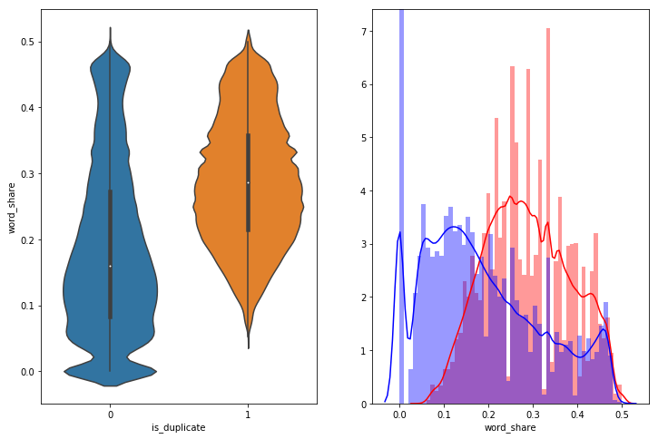

* + - * **Word Common:** it is almost overlapping

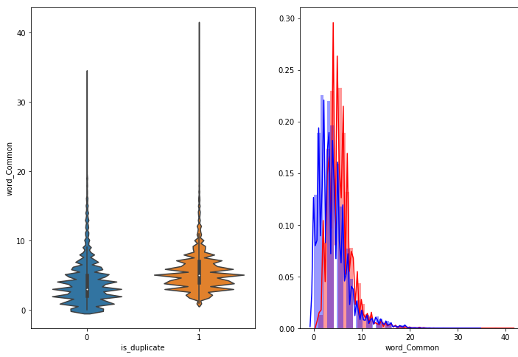

* + - * Bivariate analysis of features 'ctc_min', 'cwc_min', 'csc_min'. We can observe that we can divide duplicate and non duplicate with some of these features with some patterns.

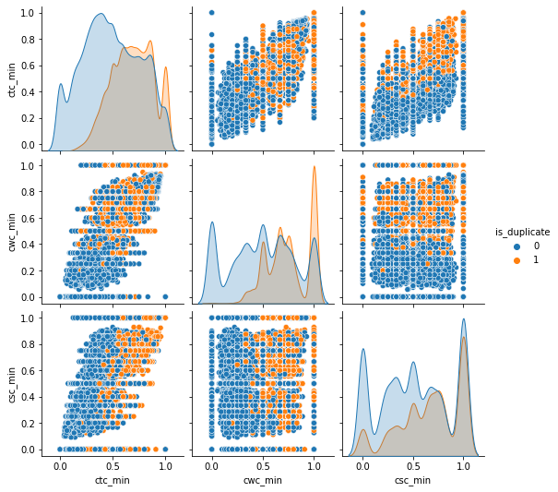

* + - * Bivariate analysis of features 'ctc_max', 'cwc_max’, 'csc_max''. We can observe that we can divide duplicate and non duplicate with some of these features with some patterns.

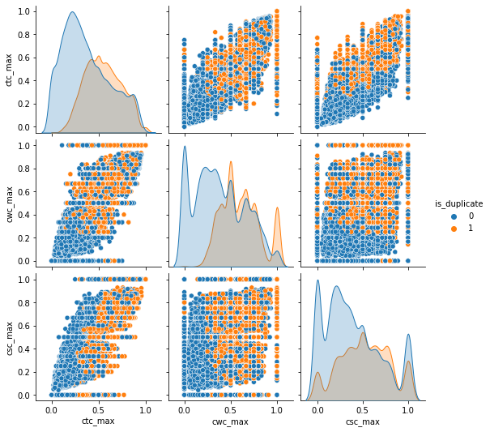

* + - * Bivariate analysis of features ‘last_word_eq’, ‘first_word_eq’. We can observe that we can divide duplicate and non duplicate with some of these features with some patterns.

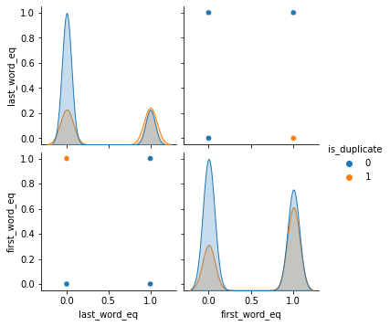

* + - * Bivariate analysis of features ‘mean_len’, ‘abs_len_diff’,’longest_substr_ratio’. We can observe that we can divide duplicate and non duplicate with some of these features with some patterns.

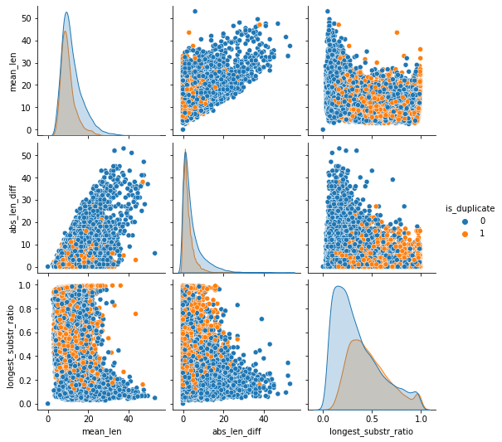

##### Applying machine learning for classification:

* + - * A model with a higher bias would not match the data set closely.
      * A low bias model will closely match the training data set.
      * Models with high bias will have low variance.
      * Models with high variance will have a low bias.
      * Characteristics of a high variance model include:
      * Noise in the data set
      * Potential towards overfitting
      * Complex models
      * Trying to put all data points as close as possible

Examples of **low-variance** machine learning algorithms include:

* + - * Linear Regression,
      * Linear Discriminant Analysis and
      * Logistic Regression.

Examples of **high-variance** machine learning algorithms include:

* + - * Decision Trees
      * k-Nearest Neighbors and
      * Support Vector Machines.

we can choose the model by using accuracy score of model, and we have

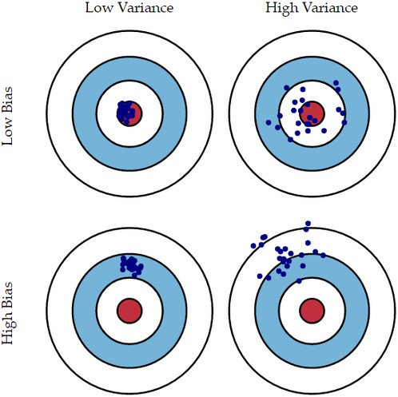

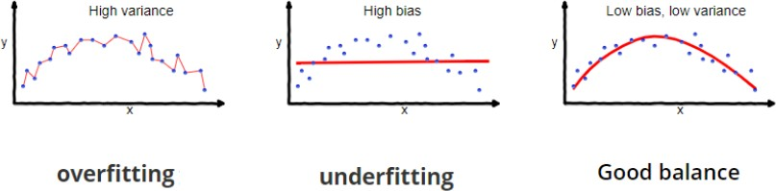

### CHAPTER-4 MACHINE LEARNING MODELS

##### RandomForest:

Random forest is a versatile machine learning method capable of performing both regression and classification tasks.Like bagging and boosting, random forest works by combining a set of other tree models. Random forest builds a tree from a random sample of the columns in the test data.

Here’s are the steps how a random forest creates the trees:

* + - Take a sample size from the training data.
    - Begin with a single node.
    - Run the following algorithm, from the start node:
      * If the number of observations is less than node size then stop.
      * Select random variables.
      * Find the variable that does the “best” job of splitting the observations.
      * Split the observations into two nodes.
      * Call step `a` on each of these nodes.
    1. Advantages:
       - Random Forest can be used to solve both classification as well as regression problems.
       - Random Forest works well with both categorical and continuous variables.
       - Random Forest can automatically handle missing values.
       - Random Forest can automatically handle missing values.
       - Random Forest is usually robust to outliers and can handle them automatically.
       - Random Forest is comparatively less impacted by noise.
    2. Limitations:
       - **Complexity:** Random Forest creates a lot of trees (unlike only one tree in case of decision tree) and combines their outputs.
       - **Longer Training Period:** Random Forest requires much more time to train as compared to decision trees as it generates a lot of trees (instead of one tree in case of decision tree) and makes decisions on the majority of votes.

##### Logistic Regression:

Logistic Regression is a supervised method of learning used for predicting the probability of a dependent or a target variable. Using Logistic Regression, you can predict and establish relationships between dependent and one or more independent variables.

Logistic Regression equations and models are generally used for predictive analytics for binary classification. You can also use them for multi-class classification.

Logistic Regression utilizes the power of regression to do classification and has been doing so exceedingly well for several decades now, to remain amongst the most popular

models. One of the main reasons for the model’s success is its power of explainability i.e. calling-out the contribution of individual predictors, quantitatively.

Unlike regression which uses Least Squares, the model uses Maximum Likelihood to fit a sigmoid-curve on the target variable distribution.The algorithm is a popular choice in many natural language processing tasks e.g. toxic speech detection, topic classification, etc.

* + 1. Advantages:
       - Logistic Regression performs well when the dataset is linearly separable**.**
       - Logistic regression is less prone to overfitting but it can overfit in high dimensional datasets. You should consider Regularization (L1 and L2) techniques to avoid over-fitting in these scenarios.
       - Logistic Regression not only gives a measure of how relevant a predictor (coefficient size) is, but also its direction of association (positive or negative).
       - Logistic regression is easier to implement, interpret and very efficient to train
    2. Limitations:
       - Main limitation of Logistic Regression is the assumption of linearity between the dependent variable and the independent variables. In the real world, the data is rarely linearly separable. Most of the time data would be a jumbled mess.
       - If the number of observations are lesser than the number of features, Logistic Regression should not be used, otherwise it may lead to overfit.
       - Logistic Regression can only be used to predict discrete functions. Therefore, the dependent variable of Logistic Regression is restricted to the discrete number set. This restriction itself is problematic, as it is prohibitive to the prediction of continuous data.

##### Decision Tree:

Decision Tree algorithm belongs to the family of supervised learning algorithms. Unlike other supervised learning algorithms, the decision tree algorithm can be used for solving regression and classification problems too.

The goal of using a Decision Tree is to create a training model that can be used to predict the class or value of the target variable by learning simple decision rules inferred from prior data(training data).

* + 1. Advantages:
       - An advantage of the decision tree algorithm is that it does not require any transformation of the features if we are dealing with non-linear data because decision trees do not take multiple weighted combinations into account simultaneously.
       - They are very fast and efficient compared to KNN and other classification algorithms.
       - Easy to understand, interpret, and visualize.
       - Normalization is not required in the Decision Tree.
       - The decision tree is one of the machine learning algorithms where we don’t worry about its feature scaling. Another one is random forests. Those algorithms are scale-invariant.
    2. Limitations:
       - Method of overfitting: If we discuss overfitting, it is one of the most difficult methods for decision tree models. The overfitting problem can be solved by setting constraints

on the parameters model and pruning method.

* + - * Reusability in decision trees: In a decision tree there are small variations in the data that might output in a complex different tree is generated. This is known as variance in the decision tree, which can be decreased by some methods like bagging and boosting.
      * It can’t be used in big data: If the size of data is too big, then one single tree may grow a lot of nodes which might result in complexity and lead to overfitting.
      * There is no guarantee to return the 100% efficient decision tree.

##### XGBOOST:

**XGBoost** is an optimized distributed gradient boosting library designed to be highly ***efficient****,* ***flexible*** and ***portable***. It implements machine learning algorithms under the Gradient Boosting framework. XGBoost provides a parallel tree boosting that solves many data science problems in a fast and accurate way. The same code runs on major distributed environment (Hadoop, SGE, MPI) and can solve problems beyond billions of example

XGBoost uses decision trees as base learners; combining many weak learners to make a strong learner. As a result it is referred to as an ensemble learning method since it uses the output of many models in the final prediction. XGBoost or Extreme Gradient Boosting! It can be put into various use cases such as ranking, classification, regression and user-defined prediction problems. It can be referred to as an "ALL in One" algorithm. It is an ideal blend of software and hardware optimization techniques to yield prevalent outcomes by using fewer computing resources in the shortest amount of time.

* + 1. Advantages:
       - It is Highly Flexible
       - It uses the power of parallel processing
       - It is faster than Gradient Boosting
       - It supports regularization
       - It is designed to handle missing data with its in-build features.
       - The user can run a cross-validation after each iteration.
       - It Works well in small to medium dataset
  1. Advantages of quora website:
     1. **Advantages :**
        + You could get much information at one place instead of going through multiple Google searches and links.
        + You could get answers from experts from across the world without even contacting them.
        + You can get and give information anonymously.
        + Quora is knowledge oriented, not person oriented. Persons with 100K upvote and 0 upvote could get banned for the same reason.
        + You could edit questions and answers anytime. You could also edit any question on quora and suggest edits for others answers.
        + You can thank people and get thanks.
        + Quora is one of the best platforms for cultural exchange. Global village? Something like that.
     2. Limitations :
        + Quora's got a bunch of great content creators, but no good way to find them.
        + It's becoming too easy for Quora to be about the answers rather than the questions
        + You have to select proper topics else you find yourself in the wrong sector of quora.

### Chapter - 5 Conclusion

In this Project, The Quora Question Pair dataset is used to predict the similarity between the two questions for duplicity using Machine Learning Algorithms. Before applying Machine Learning Models we done the Preprocessed the dataset and applied some models

and we got the results as below mentioned.

By seeing the above table we can conclude that XGBoost classifier is the efficient among all other Classification Models with an accuracy of 79.588%, followed by Random

Forest with 79.5784%, Decision Tree with 79.5784% and Logistic Regression Classifier with 72.323%.

### References

* Rishickesh Ramesh, R.P Ram Kumar, A. Shahina, Dr. A. Nayeemulla Khan “**Identification of Duplication in Questions Posed on Knowledge Sharing**

Platform Quora using Machine Learning Techniques” IJITEE Journal Paper

* AINAB IMTIAZ, MUHAMMAD UMER, MUHAMMAD AHMAD, SALEEM ULLAH, GYU SANG CHOI, ARIF MEHMOOD “**Duplicate Questions Pair Detection Using Siamese MaLSTM**”, **IEEE Journal Paper**
* Logistic Regression classifier

**“**[**https://www.geeksforgeeks.org/advantages-and-disadvantages-of-logistic-regres**](https://www.geeksforgeeks.org/advantages-and-disadvantages-of-logistic-regression/)[**sion/**](https://www.geeksforgeeks.org/advantages-and-disadvantages-of-logistic-regression/)**”**

* Random Forest

“[**https://www.analyticsvidhya.com/blog/2021/06/understanding-random-forest**](https://www.analyticsvidhya.com/blog/2021/06/understanding-random-forest)”

* Decision Tree “[**https://www.slideshare.net/DakshGoyal3/decision-tree-69802132**](https://www.slideshare.net/DakshGoyal3/decision-tree-69802132)”
* XG Boost Classifier

“https://analyticsindiamag.com/xgboost-internal-working-to-make-decision-trees

**-and-deduce-predictions**”

* [**https://github.com/UdiBhaskar/Quora-Question-pair-similarity**](https://github.com/UdiBhaskar/Quora-Question-pair-similarity)
* [**https://www.kaggle.com/code/veerpalsingh/quora-question-pair-final**](https://www.kaggle.com/code/veerpalsingh/quora-question-pair-final)
* [**https://github.com/campusx-official/quora-question-pairs/blob/main/bow-with-p**](https://github.com/campusx-official/quora-question-pairs/blob/main/bow-with-preprocessing-and-advanced-features.ipynb)[**reprocessing-and-advanced-features.ipynb**](https://github.com/campusx-official/quora-question-pairs/blob/main/bow-with-preprocessing-and-advanced-features.ipynb)
* [**https://web.stanford.edu/~jurafsky/slp3/5.pdf**](https://web.stanford.edu/~jurafsky/slp3/5.pdf)